CRUDE OIL PREDICTION

# Abstract

Given that it is the most valuable strategic resource on the planet, crude oil is the main commodity for the global economy. As a result, projecting it has proven to be challenging because numerous factors affect its price, making it challenging to predict. Crude oil prices are highly volatile and prone to change. Recently, numerous research have been carried out to examine the issue of accurately forecasting oil prices. It will be advantageous for our government, businesses, and investors to anticipate its needs. In order to estimate crude oil prices, this research requires creating artificial neural networks (ANN). In this project, we provide a cutting-edge artificial method for predicting the price of crude oil.

# Litreature Survey

**Application of Traditional and Statistical Econometric Models:**

Academic scholars were the first to utilise conventional statistical and econometric approaches among the many forecasting models created to anticipate the price of "black gold." Amano suggests the initial investigation into oil market forecasting (1987). The author used a small-scale econometric model to forecast oil markets. Huntington (1994) utilised an advanced econometric model to predict oil prices in the 1980s. In a different study, Gulen (1998) forecasted the price of WTI crude oil using cointegration analysis. Barone-adesi et al. (1998) suggested a semi-parametric method based on the filtered historical simulation technique to forecast oil prices.

In a different study, Gulen (1998) forecasted the price of WTI crude oil using cointegration analysis. Barone-adesi et al. (1998) suggested a semi-parametric method based on the filtered historical simulation technique to forecast oil prices. In order to estimate the short-term price of Brent crude oil, Morana (2001) employed a semi-parametric technique based on the GARCH features of oil price volatility that were studied by Barone-adesi et al (1998). To predict OPEC basket prices, Tang and Hammoudeh (2002) employed a nonlinear model. Ye et al. (2002, 2005) created a straightforward linear regression model for the short-term

monthly forecast of WTI crude oil spot price using OECD petroleum inventory levels and relative stock inventories. A related investigation by Ye et.

(2002, 2005) created a straightforward linear regression model for the short-term monthly forecast of the spot price of WTI crude oil using the OECD petroleum inventory levels and relative stock inventories. In a related study, Ye et al. (2006) modified the linear forecasting model presented by Ye et al. (2002, 2005) to predict short-term WTI crude oil prices by include nonlinear variables such low- and high-inventory variables. Using OECD stocks, non-OECD demand, and OPEC supply, Zamani (2004) forecasted the quarterly WTI crude oil spot price using an econometric forecasting model. Lanza and associates.

They is usage of error correction methods to analyse the price of crude oil and other products. Sadorsky (2006) used a variety of univariate and multivariate statistical models, including GARCH, TGARCH, AR, and BIGARCH, to predict daily volatility in petroleum futures price returns. With an emphasis on OPEC behaviour, Dees et al. (2007) created a linear model of the global oil market to forecast oil demand, supply, and prices. Murat and Tokat (2009) examined the connection between futures and spot crude oil prices, putting a random walk model to the test to see how well futures prices could predict spot price changes. Cheong (2009) used ARCH models to forecast the crude oil markets.

On the other hand, GARCH and different models from the GARCH family have been utilised in recent studies to forecast oil prices. For instance, using the GARCH model, Narayan and Narayan (2007) and Agnolucci (2009) predicted spot and futures crude oil prices. In a related study, Mohammadi and Su (2010) investigated the forecasting outcomes of various GARCH-type models in order to estimate the price of crude oil. CGARCH, FIGARCH, and IGARCH models were proposed by Kang et al. (2009) to predict the volatility.

The study by Kang et al. (2009) was expanded upon by Wei et al. (2010) utilising both linear and nonlinear GARCH-class models with the same objective. The use of linear approaches indicated a large discrepancy between oil price predictions and real prices. However, inventory, supply, and demand are the most often employed exogenous variables in these models to forecast oil prices. Inventory adjustments can be slow due to supply and demand being very inelastic to price changes, which accounts for a major share of the difference between actual and

predicted prices, especially in the near run (Hamilton, 2008). On the other hand, conventional statistical and economic methods often can only capture linear processes in data time series (Weigend and Gershenfeld, 1994).

**Artificial Neural Network (ANN):**

**Definition and Neuron Model Evolution**

## Definition

ANN is an input-output mathematical model that mimics how the human brain functions by adopting the same strategy for learning new things. An equivalence between a biological and an artificial neuron is shown in Fig.1

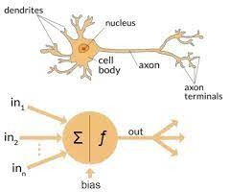

Comparison of the biological neuron (a) with the synthetic neuron (b)

**Evolution of the Neuron Model**

1. **McCulloch & Pitts' Neuron Model (1943)**

McCulloch and Pitts' model of a neuron (1943). McCulloch and Pitts proposed the first synthetic neuron, sometimes known as a formal neuron (1943). The mathematical formulation of the McCulloch-Pitts neuron model is as follows:

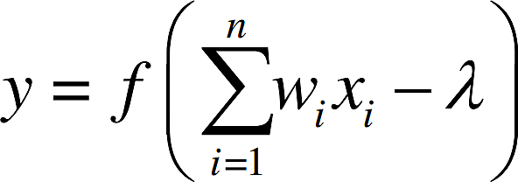

The McCulloch-Pitts neuron's inputs, which are just binary numbers (zeroes or ones), are represented by 1 2 x, x,..., n x, while the weights it receives from connections are 1 2,,..., w w wn. The McCulloch-Pitts neuron's output is denoted by y, the threshold is denoted by, and the sign function is denoted by f.

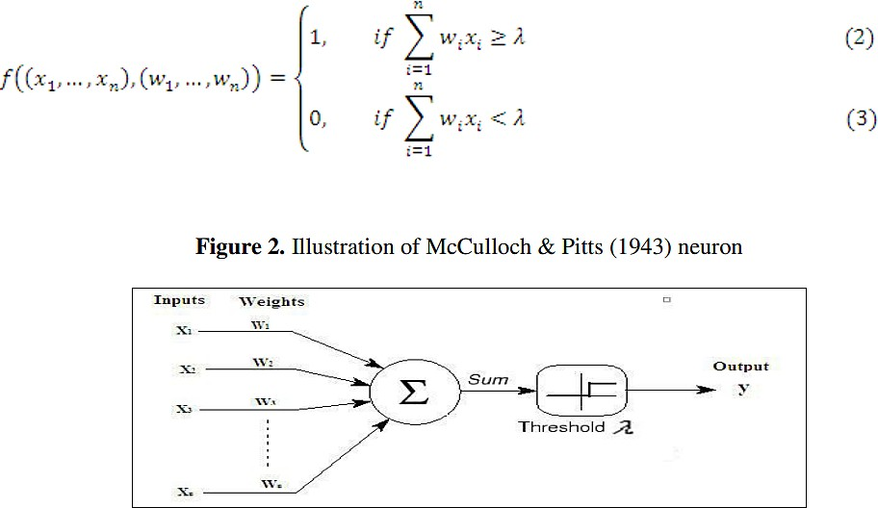

## Multilayer perceptron model

The model can only handle linearly separable functions because perceptron neural nets with no hidden layers assume only binary input-output values and only two layers. The delta rule was first put forth by Windrow and Hoff (1960). It

entails changing the connection weights in order to narrow the gap between the desired and actual output value. The output value can therefore accept any value in place of 0 and 1.

Minsky and Papert (1969) emphasised the value of incorporating one or more hidden layers to identify the complex properties contained in the inputs in their book. The learning algorithm developed by Rumelhart et al. backpropagation has traditionally been used to train multilayer perceptron nets (described in the following section) (1986).

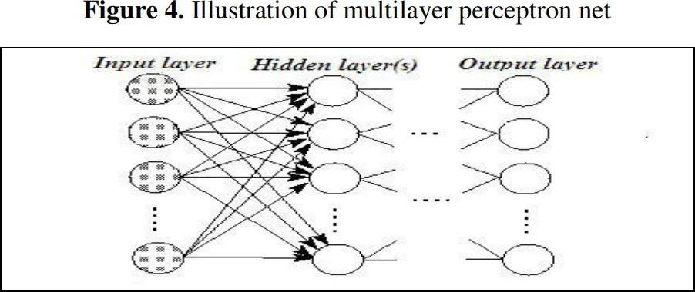

In this network structure, information spreads in a single direction—forward—from the input units to the neurons in the first hidden layer, and then from the first hidden layer's outputs to the next layer and so on. The network output as a result is as follows (for instance, with one hidden layer):

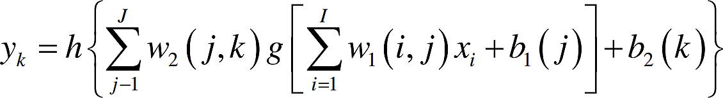

Where I x represents the input variables for the network, I represents the total number of input variables, J represents the total number of nodes in the hidden layer, and K represents the total number of neurons in the output layer. The first and second layers' respective transfer/activation functions are denoted by the letters g and h; The weights matrix for the hidden layer is w1, while the weights matrix for the output layer is w2. It should be noted that at least one transfer

function of the hidden layer (which is further defined in the following section) must be nonlinear. The bias vectors of the hidden layer are 1 b and 2 b. (Hornik et al., 1989).

**REFERENCE**

1. "Improved Forecast Ability of Oil Market Volatility Based on Integrated Markov Switching and GARCH-class Model," Yu Runfang, Du Jiangze, and Liu Xiaotao, Procedia Computer Science, vol. 122, pp. 415-422, 2017.
2. "LSTM: A Search Space Odyssey," IEEE Transactions on Neural Networks and Learning Systems, vol. 28, no. 10, pp. 2222-2232, Oct. 2017. K. Greff, R. K. Srivastava, J. Koutnak, B. R. Steunebrink, and J. Schmidhuber.
3. Ehsan Khamehchi and Mohammad Reza Mahdiani published "A modified neural network model for predicting the crude oil price" in Intellectual Economics, vol. 10, no. 2, in August 2016.
4. "Forecasting Crude Oil Price Using Artificial Neural Networks: A Literature Survey," Economics Bulletin, AccessEcon, vol. 35, no. 2, 2015, pp. 1339–1359. Manel Hamdi and Chaker Aloui.
5. Aloui, Chaker, and Manel Hamdi (2015). Artificial Neural Networks for Crude Oil Price Prediction: A Literature Review. 1339–1359 in Economics Bulletin, No. 35.